Project Design Phase-II
Data Flow Diagram & User Stories

Date | 30 September 2026
Team ID | SWTID-2026-7082
Project Name | Implement Client Script & UI Policy (Incident)
Maximum Marks | 4 Marks

Data Flow Diagrams:
A Data Flow Diagram (DFD) is a traditional visual representation of the information flows within a system. A neat and clear DFD can depict the right amount of the system requirement graphically. It shows how data enters and leaves the system, what changes the information, and where data is stored.

Example: (Simplified)

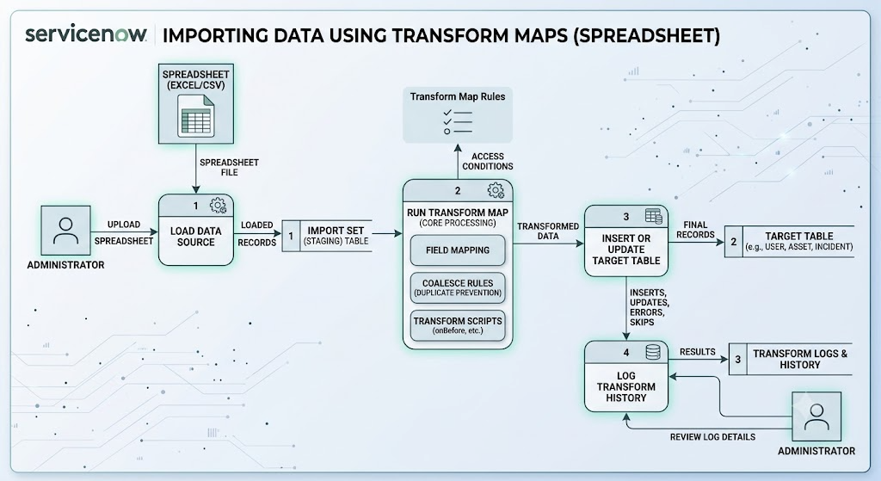

User Stories
Use the below template to list all the user stories for the product
User Type | Functional Requirement (Epic) | User Story Number | User Story / Task | Acceptance criteria | Priority | Release
ServiceNow Administrator | Data Loading | USN-1 | As an admin, I can upload a spreadsheet into a Data Source so that raw data is ingested into the system. | Spreadsheet data successfully loads into the Import Set (staging) table without file format errors. | High | Sprint-1
 | Field Mapping | USN-2 | As an admin, I can create a Transform Map to link staging table columns to target table fields. | Auto-mapping correctly links matching names; remaining fields can be mapped manually using the Mapping Assist tool. | High | Sprint-1
 | Duplicate Prevention | USN-3 | As an admin, I can set a unique identifier (e.g., Email or ID) as a 'Coalesce' field. | If a record with that identifier exists, it updates the record. If not, it creates a new record. No duplicates are created. | High | Sprint-1
 | Reference Handling | USN-4 | As an admin, I can set a "Choice Action" for reference fields so the system knows what to do with un-matched data. | Un-matched reference data is either ignored, rejected, or creates a new choice based on configuration. | Medium | Sprint-2
ServiceNow Developer | Data Formatting | USN-5 | As a developer, I can write a Transform Script (e.g., onBefore) to standardize incoming text formats before insertion. | Data like names or dates are reformatted to match system standards before hitting the target table. | Medium | Sprint-2
Data Owner / Manager | Error Monitoring | USN-6 | As a data owner, I can view the Transform History logs after an import runs. | I can see a clear count of Inserts, Updates, Ignored, and Error rows with reasons for any failures. | High | Sprint-1
 | Execution | USN-7 | As a data owner, I want to execute the Transform process securely without needing full admin access to the database. | I can trigger the data load and transform without impacting live system performance or bypassing security rules. | Low | Sprint-3

